**In-class assignments 3**: Image analysis tool is highly suggested because it is flying processing.

First, join two rasters together using mosaic tool.

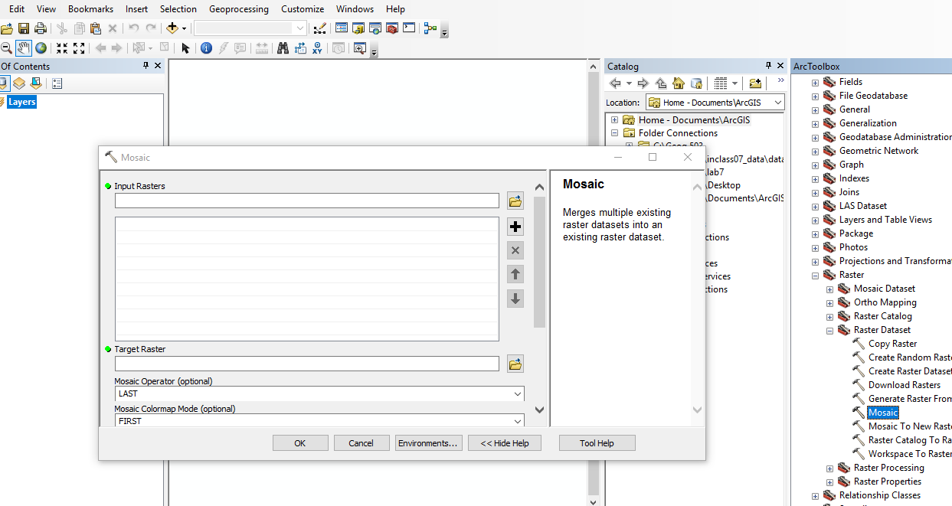

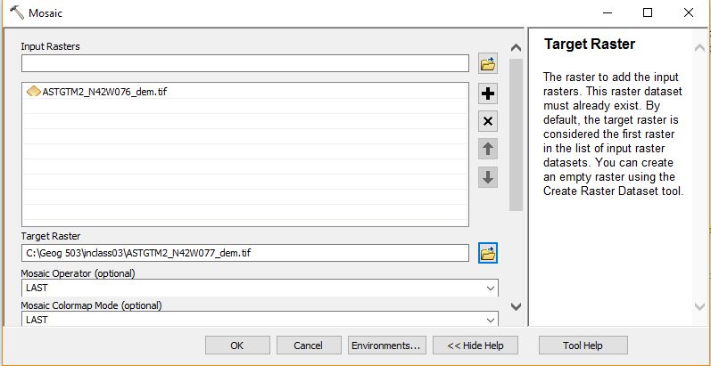

Extract raster based on broome county tool, using spatial analyst tool – extraction – extraction by mask.

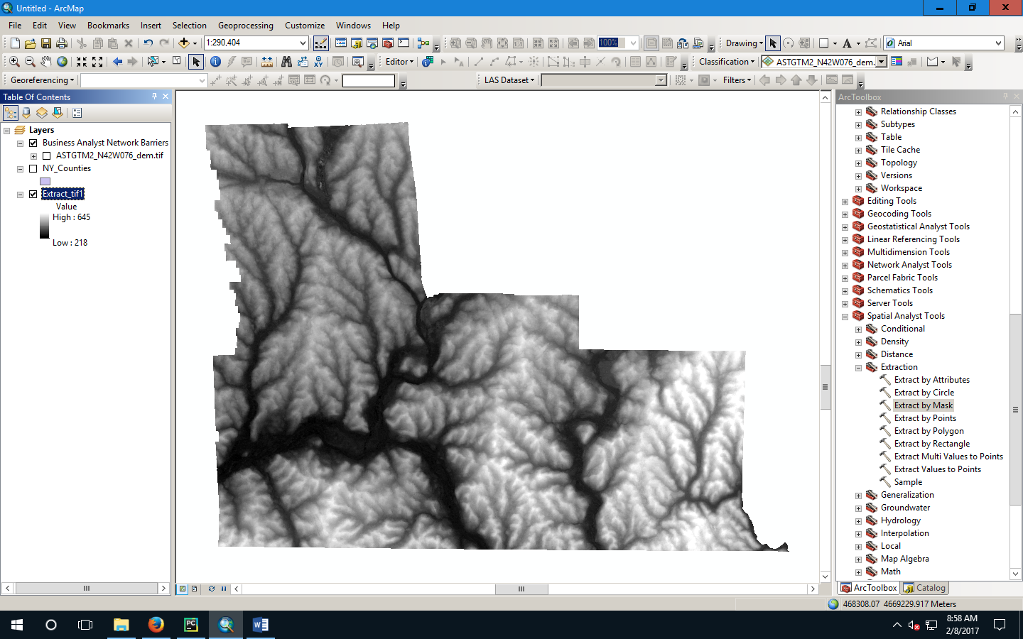

On feature class, we can zoom in to find the selected raster. But in raster, we cannot. So, to find the highest location:

Use spatial analyst – map algebra – raster calculator – Conditional – con – (raster == 645,1,0) - get a new binary raster – zoom in

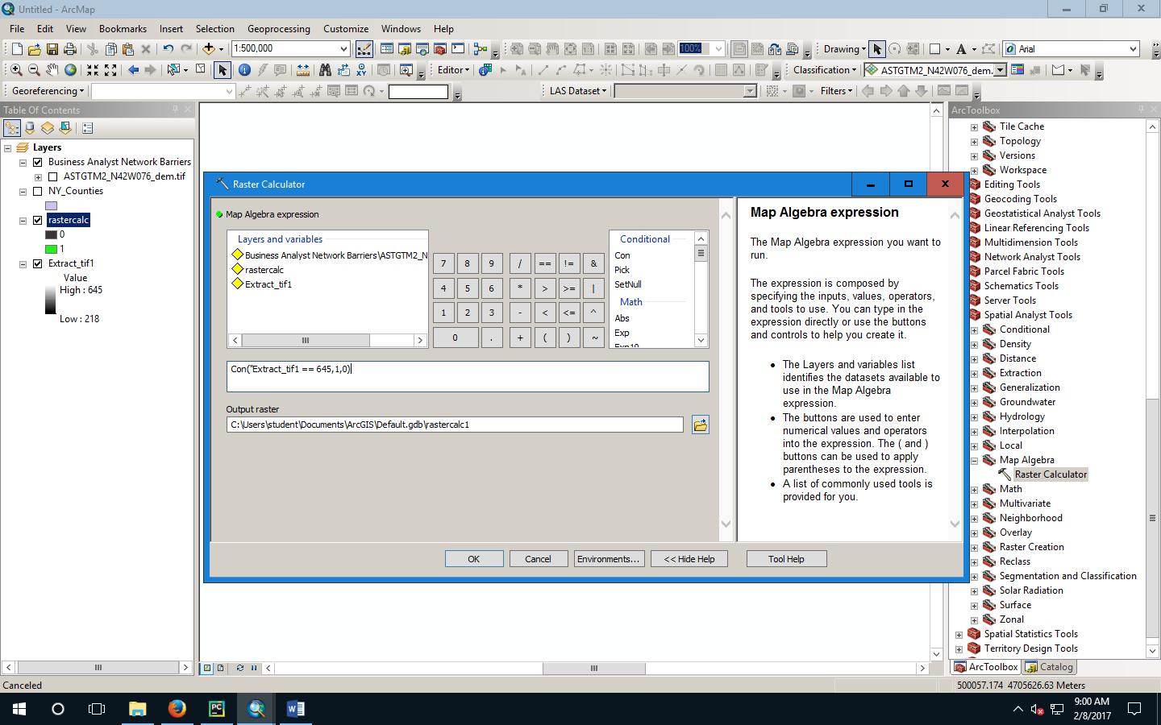

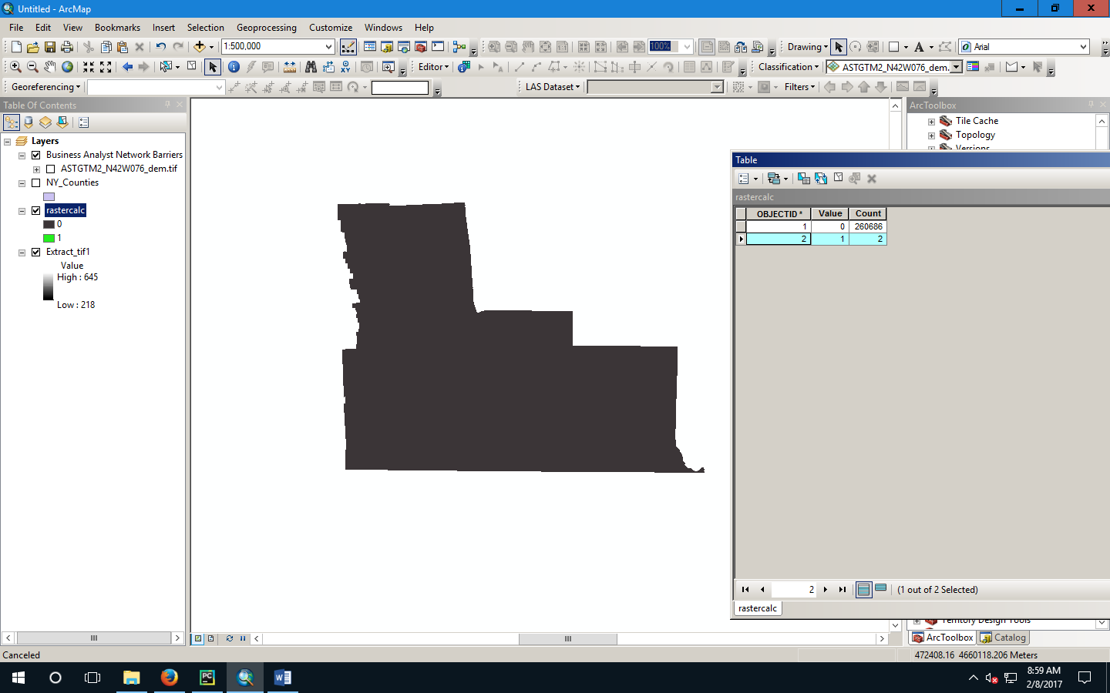

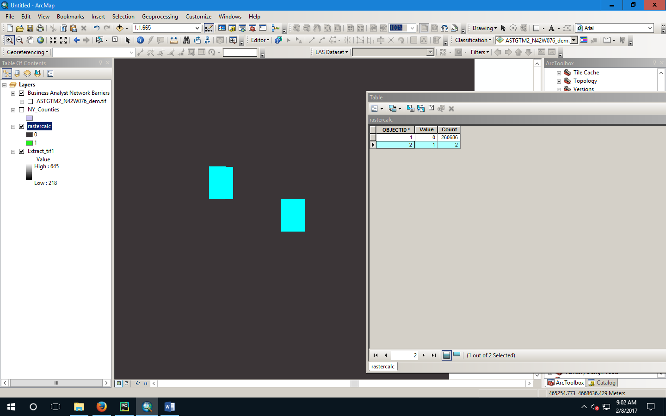

Summary statistics is used to calculate max, min, and average.

Codes

how to export output to .py

Go to result

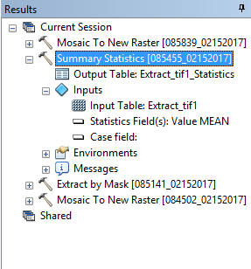

Pull them to python window

copy codes.